Chapter 5, Solution 73.

Determine the load voltage v_{L} in the circuit of Fig. 5.99.
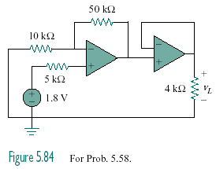

Figure 5.99
For Prob. 5.73.

Solution

The first stage is a noninverting amplifier. The output is

The second stage is another noninverting amplifier whose output is
10.8V

